Task-1 Draw a labeled diagram of a typical home Wi-Fi setup showing a modem, router, switch, access point, and at least two devices (like a laptop and smartphone) connected to the network.
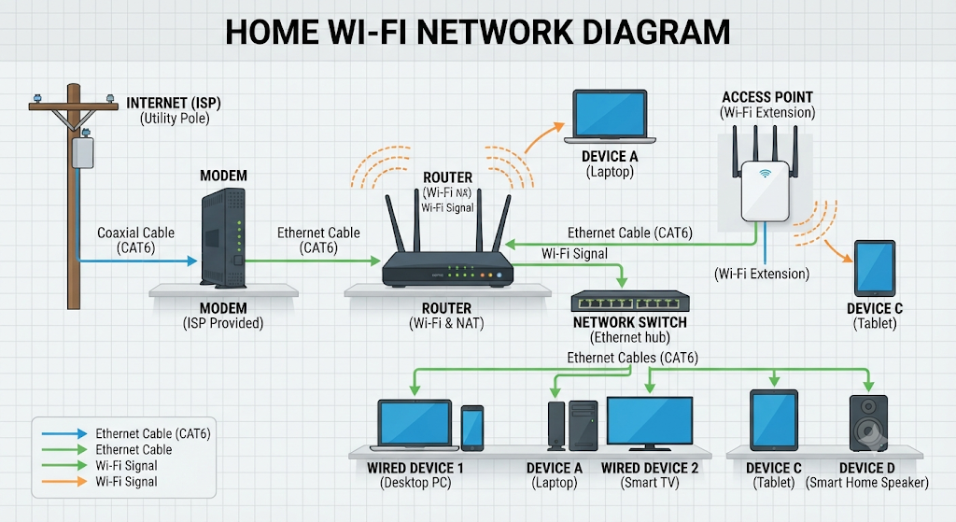

Task-2 List the main function of each networking hardware device: modem, router, switch, access point, and network cable. For each, give a real-life example of where you might see or use it (for example, 'router: at home to share internet').

Here is a breakdown of the main functions and real-life examples for each key networking hardware device:

1. Modem (Modulator-Demodulator)
- Main Function: Translates incoming analog signals from your Internet Service Provider (ISP)—via cable, fiber, or DSL—into digital data that your computer and network can understand, and vice versa.

- Real-Life Example: Sitting on a shelf near a cable outlet in your living room, bridging your home network to the outside internet service provided by companies like Comcast or Verizon.

2. Router
- Main Function: Connects multiple networks together (typically your home network to the internet), directs data traffic (packets) between them, and assigns local IP addresses to your devices using DHCP.

- Real-life Example: Placed centrally in a home to allow all your smartphones, laptops, and smart appliances to share a single internet connection safely behind a firewall.

3. Switch
- Main Function: Connects multiple wired devices together on a single local area network (LAN) using Ethernet ports, forwarding data directly to the intended destination device rather than broadcasting it to all ports.

- Real-life Example: Used in a home office or entertainment center setup to plug in a desktop PC, a gaming console, and a network-attached storage (NAS) drive when the router doesn't have enough physical ports.

4. Access Point (AP)
- Main Function: Adds Wi-Fi capability to a wired network or extends the wireless coverage area by creating a separate wireless local area network (WLAN).

- Real-life Example: Mounted on the ceiling of the second floor in a large multi-story home or a corporate office building to provide strong wireless signals to areas where the main router's Wi-Fi cannot reach.

5. Network Cable (e.g., Ethernet Cable / CAT6)
- Main Function: Provides a physical, high-speed, and interference-free wired pathway for data to travel between networking devices.

- Real-life Example: Running a blue or yellow cable from your wall router directly into the back of your desktop computer or smart TV for a stable connection during online gaming or 4K streaming.

Task-3 ake photos or find images online (with source links) of at least three types of network cables (such as Ethernet, coaxial, fiber optic) and write one line describing where each is commonly used.

Here are three common types of network cables along with their typical usage:

Coaxial Cable

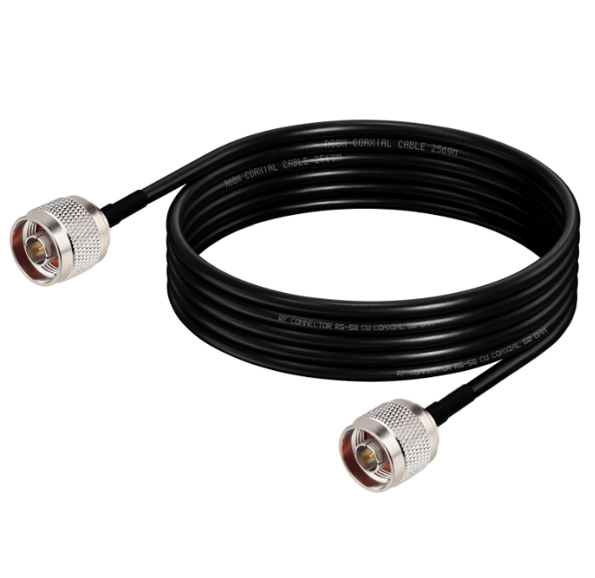
- Commonly used for: Delivering cable television broadcasts and broadband internet signals from an outdoor utility line or wall plate directly into a cable modem or set-top box.

- Source: Netboon

Ethernet Cable (RJ45 Patch Cord)

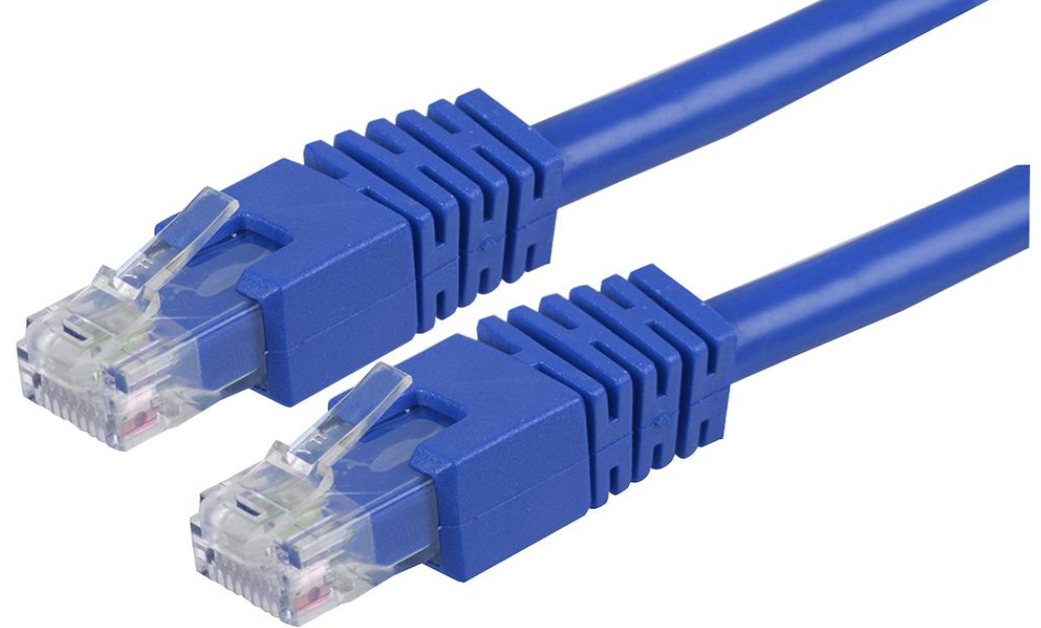
- Commonly used for: Connecting local wired hardware—such as desktop computers, network switches, smart TVs, and gaming consoles—directly to a Wi-Fi router for a stable, high-speed wired connection.

- Source: Element14

Fiber Optic Cable

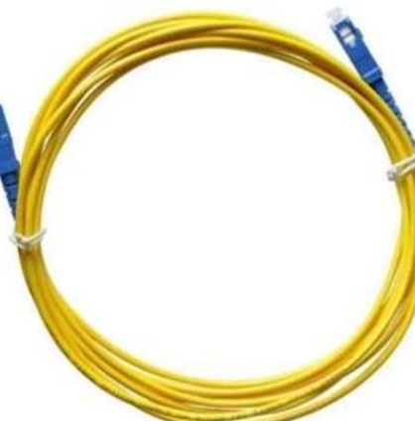
- Commonly used for: High-speed, long-distance data transmission, connecting FTTH (Fiber-to-the-Home) wall terminals to optical network modems, or linking enterprise data centers.

- Source: Moglix

Task-4 Create a comparison table listing at least four differences between a router and a switch, including their main use, typical location, and how they handle data.

Here is a comparison table outlining four key differences between a network router and a network switch:
Feature / Aspect | Router | Switch
1. Main Use | Connects different networks together (such as your home network to the internet) and manages traffic between them. | Connects multiple devices together within a single local area network (LAN) using Ethernet ports.
2. Typical Location | Placed at the edge of the network where the internet service provider (ISP) connection enters the home or office. | Placed locally inside a home office, entertainment center, or server rack where multiple wired devices congregate.
3. How They Handle Data | Directs data between different networks (using IP addresses) and routes internet packets across the globe. | Forwards data within the same network by sending frames directly to the specific destination device using MAC addresses.
4. Device Connections | Typically features one WAN port (for the modem) and a few LAN ports, often combining wired connections with Wi-Fi. | Features multiple Ethernet ports (e.g., 5, 8, 16, or 24 ports) dedicated entirely to plugging in wired hardware.

